Creating Mobile Applications Using the HealthVault iOS Library
The Microsoft© HealthVault™ platform allows mobile applications to connect directly to the HealthVault Service and to utilize User Authorized HealthVault records in mobile applications. The HealthVault iOS Library handles authentication and other routine operations when accessing HealthVault.
This document describes the HealthVault iOS Library, which handles all major integration with the HealthVault functionality, in order to simplify iOS applications development for Native HealthVault Connection.

HealthVault Platform for Mobile Applications
This section describes the process of connecting to the HealthVault pre-production environment. The “Go Live” process to deploy an application on the production HealthVault service can be found here.
Information about the API provided by the HealthVault service can be found here.
Mobile support is built upon a capability we call Software on Device Authentication (SODA). The developer registers a master application using the Application Configuration Center and marks that application as a SODA application. This enables the mobile application to create child applications using this master application.
The process of setting up a mobile application to use the HealthVault service is known as “provisioning,” and consists of the following steps:

Obtaining child application information
The application calls the HealthVault service to obtain an identifier for the child application and a shared secret.

Creating and authorizing the application
The application sends the child application information to the HealthVault Shell web site. The user performs the following steps:
- Create a HealthVault account, or authenticate if they already have an existing account
- Indicate which record(s) should be accessible to the application, and grant access.
The HealthVault Shell then sends this information to the HealthVault Service, which creates the child application and stores the authorization information. As part of the authorization process, the application creates a X.509 certificate to the public key, which is stored by HealthVault and which is then used to identify the application.

Connecting and obtaining user information
Now the mobile application can call into the HealthVault service and obtain information about the user and the record(s) that were authorized.
When this operation is completed, the application can access the record to read and write health data.

HealthVault iOS Library Overview

The HealthVault iOS Library (HVMobile) is an Objective-C library which can assist in the integration of HealthVault and the iOS application.
HVMobile provides a simple way to connect your iPhone or iPad application to the HealthVault platform. It handles much of the complexity involved in integrating a mobile application with the HealthVault platform described in the section above, in particular it:
- handles application authorization with the Healthvault platform;
- creates and performs custom requests to the HealthVault platform and handles the responses;
- provides persistence functionality to save all essential parameters between application sessions;
- includes a sample application demonstrating uses of the library, including in-browser authorization capabilities.

The library package consists of the following components:
- The library itself (classes\HVMobile).
- The sample application (classes\Sample) which demonstrates uses of the library.
To run the sample application you should select HVMobile as Active Target in Xcode (selected by default) and then execute a Run command. After the authorization process is completed you will be able to track your weight information, save weight measurements, and remove saved measurements.
- Unit tests (classes\Tests) which cover both the library and the demo application:
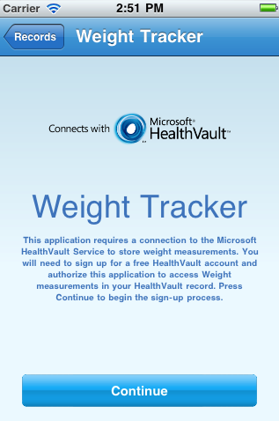 | 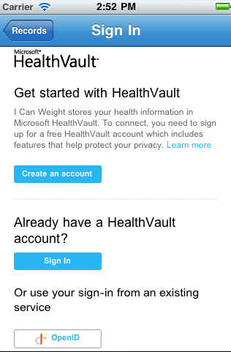 | 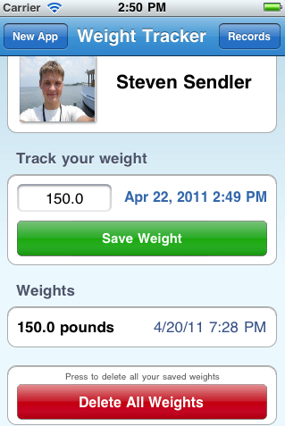
You don’t need to install additional software to run tests; Xcode is already configured for unit testing. You must select HVMobileTests as the Active Target in Xcode and then execute a Build command. All tests will run as part of the build process, and execution results will appear in the Build Results window.

Adding HVMobile to a Project
To install the library to your project, you only need to copy your library files.
- Open both the HVMobile project and your app's project in XCode.
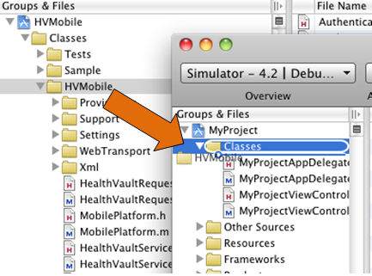
- Drag the classes\HVMobile Group from the library project into your project's Groups & Files.

Make sure the "Copy items into destination group's folder (if needed)" checkbox is checked.

Now you can import the HealthVaultService.h file to start using the library functionality.

Using the Library
At startup, the application must create an instance of the HealthVaultService class, restore the previously saved state, and call performCheckAuthentication before performing any HealthVault operations.
For example,
// Create service instance.
_healthVaultService = [[HealthVaultService alloc] initWithUrl: HEALTH_VAULT_PLATFORM_URL
shellUrl: HEALTH_VAULT_SHELL_URL
masterAppId: HEALTH_VAULT_MASTER_APPLICATION_ID];
// Load service state.
[_healthVaultService loadSettings: @"Default"];

// Authenetication status check.
[_healthVaultService performAuthenticationCheck: self
authenticationCompleted: @selector(authenticationCompleted:)
shellAuthRequired: @selector(shellAuthRequired:)];

The shellAuthRequired handler means that you should authorize the application before proceeding. To do so you should perform a web authentication following the address provided by the getApplicationCreationUrl method:

[_healthVaultService getApplicationCreationUrl]

When an authenticationCompleted handler is called the application must set the currentRecord property if it has not already been set. For example, the method handler may look like the following:

- (void)authenticationCompleted: (HealthVaultResponse *)response {

// Save current state of HealthVault service
[_healthVaultService saveSettings: @"Default"];

if (response.hasError) {
[self showAlertWithError: response.errorText];
return;
}

// Select the first record by default
if (_healthVaultService.currentRecord == nil &&
_healthVaultService.records != nil &&
_healthVaultService.records.count > 0) {

_healthVaultService.currentRecord = [_healthVaultService.records objectAtIndex: 0];
}

}

It is essential to save the service state in both handlers using the saveSettings method. For example:
[_healthVaultService saveSettings: @"Default"];

To send a request to the HealthVault service, the application does the following:
- Create an instance of the HealthVaultRequest class, which defines the method to be called, the information to be passed, and a completion handler to be called when the request is finished.
- Call HealthVaultService sendRequest and pass in the request instance.
- In the completion handler, check for errors by looking at the hasError property on the event arguments.
- If the hasError property is False, the request was successful and the returned XML can be processed.
For example:
// Loads all weights for current record.
+ (void)loadWeights: {

// Prepares xml for retrieving weights.
NSString *xml =
@"<info>"
"<group>"
"<filter>"
"<type-id>3d34d87e-7fc1-4153-800f-f56592cb0d17</type-id>"
"<thing-state>Active</thing-state>"
"</filter>"
"<format>"
"<section>core</section>"
"<xml/>"
"<type-version-format>3d34d87e-7fc1-4153-800f-f56592cb0d17</type-version-format>"
"</format>"
"</group>"
"</info>";

// Sends request to retrieve the weights.
HealthVaultRequest *request = [[HealthVaultRequest alloc] initWithMethodName: @"GetThings"
methodVersion: 3
infoSection: xml
target: target
callBack: selector(loadWeightsCompleted:)];
[_healthVaultService sendRequest: request];
[request release];
}
// Callback for loading weights server request.
- (void)loadWeightsCompleted: (HealthVaultResponse *)response {

if (response.hasError) {
[self showAlertWithError: response.errorText];
return;
}

// Information is stored in response.infoXml property.
_weights = [[Weight parseWeightsFromXml: response.infoXml] retain];
}
Configuring the library
There are special configuration values specified in HealthVaultConfig.h which you can use to configure the library. For example:
HEALTH_VAULT_TRACE_ENABLED
If TRUE then the library traces all requests, responses and other debug information to a console. By default, this is enabled in debug mode and disabled in Release.
DEFAULT_LANGUAGE
Language identifier if not specified, “en” by default.
DEFAULT_COUNTRY
Country code identifier if not specified, “US” by default.
HEALTH_VAULT_PLATFORM_URL, HEALTH_VAULT_SHELL_URL
HealthVault platform and shell urls if not specified, by default https://platform.healthvault-ppe.com/platform/wildcat.ashx" and https://account.healthvault-ppe.com, correspondingly.

Debugging
For easy troubleshooting, the library leverages a special tracing system which by default is enabled in Debug mode and disabled in Release. This behavior is defined in the HealthVaultConfig.h file and can be adjusted per your application needs.
There is also an additional trace option which specifies whether or not to trace all communication messages passed to or received from the HealthVault platform – the WebTransport setRequestResponseLogEnabled method call, for example:
[WebTransport setRequestResponseLogEnabled: TRUE];
Please note that the general trace logic and request/response log are independent, so you can enable one of them and disable the other.
Accessing trace output
The library redirects all output traces either to an Xcode console or to a special file, according to device type:
- On a simulator all messages are written to an XCode Console window.
- On a real device the messages are written to file “appLog[timestamp].txt” in the Documents folder of your application so that you can later read them.

Localizing to other Languages

The library includes multilingual support via resource files. By default the package includes US English (en-us) language only. Use the instructions below to add additional supported languages. The iOS will then automatically select the appropriate language according to the device settings/language.

- Run XCode and navigate to a Localizable.strings group located under the Resources folder (HVMobile\Resources). Right click on Localizable.strings and select “Get Info.” Then, in the “General" tab, click the "Add Localization" button.
- Choose the necessary localization language from the drop down list (e.g. Japanese or French) and press "Add."
- New localization and the corresponding resource file will be added to a Localizable.strings group. Adjust key/value pairs for the added language.

Please note that strings have special formatting constructions (%d or %@), your localized strings should also have these constructions for correct library work.

For more instructions on how to make localization adjustments, please see http://developer.apple.com/library/ios/#documentation/MacOSX/Conceptual/BPInternational/BPInternational.html.

Further Reading and Useful Links
Working with Data Types
There is a list of all the current data types on the HealthVault developer center. You can use the schemas through whatever XML serialization your platform provides, or by hand-crafting the XML.
References
http://msdn.microsoft.com/en-us/healthvault/bb962148.aspx
http://www.microsoft.com/downloads/en/details.aspx?FamilyID=721eed65-4758-4b0e-8c02-68b0e321f31b
https://config.healthvault-ppe.com/
https://developer.apple.com/library/ios/#documentation/Xcode/Conceptual/iphone_development/135-Unit_Testing_Applications/unit_testing_applications.html
http://developer.healthvault.com/pages/types/types.aspx
http://msdn.microsoft.com/en-us/healthvault/cc135993

